
FACULTY OF ENGINEERING AND TECHNOLOGY
COURSE UNIT; COMPUTER PROGRAMMING
COURSES; AMI, APE, WAR, MEB
GROUP D
GROUP MEMBERS
NAME | COURSE | REG NUMBER
KATUMBA JEREMIAH | AMI | BU/UP/2024/5252
KAKURU OBADIAH | WAR | BU/UP/2024/1029
SSEBAKIJJE HOSEA | AMI | BU/UP/2024/0847
LWASAMPIJJA ASHIRAF | AMI | BU/UP/2024/5253
CHRISTOPHER ROM NYEKO | WAR | BU/UP/2024/1O69
AUJO EVERLYN | AMI | BU/UP/2024/3223
ADIPO HOPE ODWARE | MEB | BU/UP/2024/0980
KOBUSINGYE BETHLINE | PTI | BU/UG/2024/2602
RUBANGAKENE GEOFFERY | WAR | BU/UP/2024/3260
GUDOI ALLAN | WAR | BU/UP/2024/4449
OKOTH DONANTO MEMORY | AMI | BU/UP/2023/1041
ACHAM LOYCE | AMI | BU/UP/2024/0821
BINYWERA NICHOLAS | WAR | Bu/up/2024/3249
KAKUMBA ISSAC SSEMBOGO | WAR | BU/UP/2024/2593
OCEN PAUL ENYARU | AMI | BU/UP/2023/1066
ETYANG JONATHAN | APE | BU/UG/2024/2671
ESARAIT BRIAN | MEB | BU/UP/2024/5343

DATE OF SUBMISSION: ………………………………
SUBMITTED TO: …………………………………
SIGNATURE: ……………………………………………..

Table of Contents
ACKNOWLEDGEMENT iv
ABSTRACT v
DEDICATION. vi
DECLARATION vii
APPROVAL 8
CHAPTER ONE INTRODUCTION 9
HISTORICAL BACKGROUND 9
Historical Background 9
STUDY METHODOLOGY 9
NUMBER ONE 9
STEPS INVOLVED 10
Part (ii) of question one 12
Part (iii) 13
QUESTION TWO 14
STEPS INVOLVED 14
QUESTION TWO 14
Conclusion 15

ACKNOWLEDGEMENT
First and foremost, we would like to thank the Almighty God for giving us the knowledge and guidance while doing our assignment as group D. We extend our gratitude to all the persons with whose help we managed to make it this far
The the love of every group member to invest time and provide all they could to see the assignment a success. Finally, we would like to express our gratitude to all the sources and references that have been cited in this report

ABSTRACT
We started our first meeting for research on 5th, September, 2025 in the university library out of which we were exposed to various concepts on how to interact with the matlab interface, import, extract and feeding in data in to MATLAB as per the assignment which consisted of retrieving excel data from Kaggle.com website ,copying variables of each year to tables, converting tables to structural arrays, outputting each variable in to a single work book and generating a MATLAB code that can store each members’ affirmation attributes, we managed to achieve this through group work and division of tasks

DEDICATION.
We dedicate this report to all Group D members, who have been there with us in the process of researching and doing the and compiling this report. To our lecturer Mr. Maseruka Benedicto whose guidance and expertise have been so needful , your mentorship and lecturing has built our understanding.

DECLARATION

We declare that this information in this report is our own, to the best of our knowledge.

APPROVAL
We are presenting this report which has been written and produced under our efforts. We carried out research on converting tables into structural arrays, outputting variables into single workbooks and writing codes that can store affirmation attributes.

CHAPTER ONE INTRODUCTION

HISTORICAL BACKGROUND
MATLAB, which stands for matrix laboratory, is a high-performance programming language and environment designed primarily for technical computing. Its origins trace back to the late 1970s when Cleve Moler, a professor of computer science, developed it to provide his students with easy access to mathematical software libraries without requiring them to learn Fortran.
MATLAB is built around the concept of matrices, making it particularly effective for linear algebra and matrix manipulation.It provides a vast library of built-in functions for mathematical operations, statistics, optimization, and other specialized tasks.
MATLAB offers powerful tools for creating 2D and 3D plots, enabling users to visualize data effectively.Specialized toolboxes extend MATLAB's capabilities, providing functions tailored for specific applications like signal processing, image processing, control systems, and machine learning.
MATLAB can interface with other programming languages (like C, C++, and Python) and software tools, allowing for flexible integration into larger systems. Its interactive environment features a command window, workspace, and editor, making it accessible for both beginners and advanced users.

Historical Background
The first version of MATLAB was created in Fortran in the late 1970s as a simple interactive matrix calculator. This early iteration included basic matrix operations and was built on top of two significant mathematical libraries: LINPACK and EISPACK, which were developed for numerical linear algebra and eigenvalue problems, respectively.
Recent versions of MATLAB have introduced features like the Live Editor, which allows users to create interactive documents that combine code, output, and formatted text. This evolution reflects MATLAB's ongoing adaptation to meet the needs of its diverse user base across academia and industry.

STUDY METHODOLOGY

Introduction
At the start, each member was given a task of making research about the assignment before our first meeting. The research concepts were obtained through watching tutorials on U-tube and also consultations from other continuing students especially those in year three and four.

NUMBER ONE
There is a website on the internet called kaggle. Com each group should be able to retrieve a unique data set in excel format. The group will read this data set into Mat lab in one code, they will be able to copy variables of each year and put them in the following;
1. Tables for each year of data
2. Convert the tables in 1 above into structural arrays
3. Output each of the variables in 2 above into a single workbook with each year on separate sheets having clear column headings sheet names

STEPS INVOLVED
Step1; Open Kaggle.com website from goggle chrome.
Step2; sign in Kaggle.com and download any desired excel dataset and zip it in to a desired folder.
Step 3; Open the file and copy the link path into MATLAB.
Step4; go to Home tab and click on new script to open the editor.
Step 5; save the script . And save it in the directory that is in your MATLAB path or current working directory.
Step 6. ; insert the required codes respectively and then run as shown below,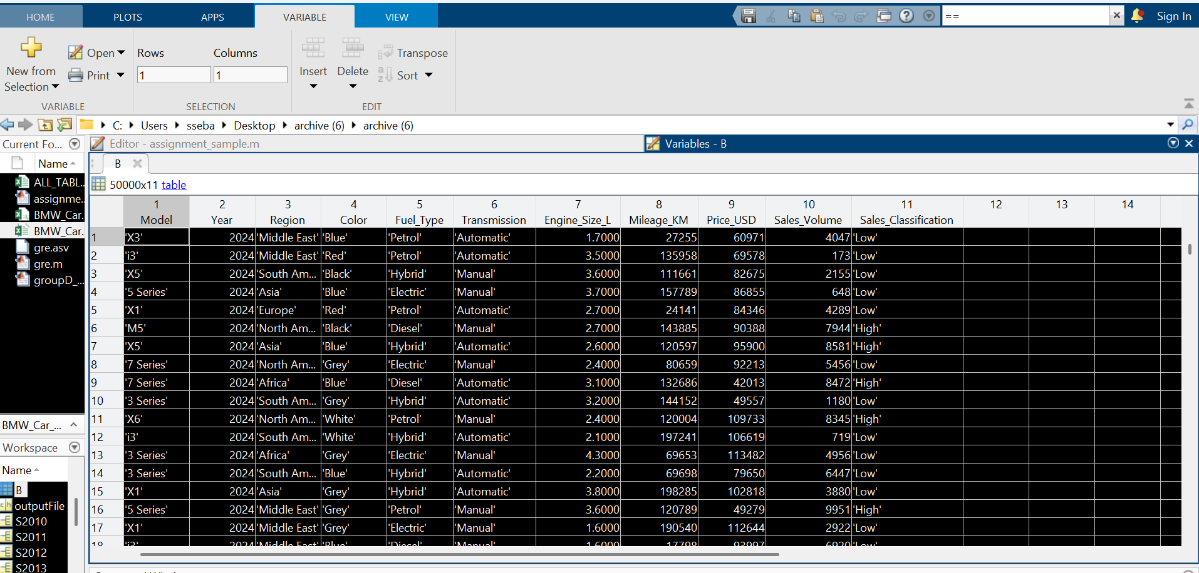
Mat lab code for number one
NUMBER ONE
%reading an excell sheet into matlab
clc; clear;
%reading of the table
B=readtable('C:\Users\Administrator\Desktop\archive (6)\BMW_Car_Sales_Classification.xlsx','Sheet','BMW_Car_Sales_Classification','Range','A1:K50001')
% extraction of unique years(2024)
T2024=B(B.Year==2024, : );%extraction of unique years(2024)
T2023=B(B.Year==2023, : );%extraction of unique years(2023)
T2022=B(B.Year==2022, : );%extraction of unique years(2022)
T2021=B(B.Year==2021, : );%extraction of unique years(2021)
T2020=B(B.Year==2020, : );%extraction of unique years(2020)
T2019=B(B.Year==2019, : );%extraction of unique years(2019)
T2018=B(B.Year==2018, : );%extraction of unique years(2018)
T2017=B(B.Year==2017, : );%extraction of unique years(2017)
T2016=B(B.Year==2016, : );%extraction of unique years(2016)
T2015=B(B.Year==2015, : );%extraction of unique years(2015)
T2014=B(B.Year==2014, : );%extraction of unique years(2014)
T2013=B(B.Year==2013, : );%extraction of unique years(2013)
T2012=B(B.Year==2012, : );%extraction of unique years(2012)
T2011=B(B.Year==2011, : );%extraction of unique years(2011)
T2010=B(B.Year==2010, : );%extraction of unique years(2010)
% %coversion of tables into struct
%for T2024
S2024=table2struct(T2024);
%for T2023
S2023=table2struct(T2023);
%for T2022
S2022=table2struct(T2022);
%for T2021
S2021=table2struct(T2021);
%for T2020
S2020=table2struct(T2020);
%for T2019
S2019=table2struct(T2019);
%for T2018
S2018=table2struct(T2018);
%for T2017
S2017=table2struct(T2017);
%for T2016
S2016=table2struct(T2016);
%for T2015
S2015=table2struct(T2015);
%for T2014
S2014=table2struct(T2014);
%for T2013
S2013=table2struct(T2013);
%for T2012
S2012=table2struct(T2012);
%for T2011
S2011=table2struct(T2011);
%for T2010
S2010=table2struct(T2010);
%
% %generation of a workbook
outputFile = 'C:\Users\Administrator\Desktop\archive (6)\ALL_TABLES.xlsx';
%writing each table to a different sheet
writetable(T2024,outputFile,'Sheet','T2024');
writetable(T2023,outputFile,'Sheet','T2023');
writetable(T2022,outputFile,'Sheet','T2022');
writetable(T2021,outputFile,'Sheet','T2021');
writetable(T2020,outputFile,'Sheet','T2020');
writetable(T2019,outputFile,'Sheet','T2019');
writetable(T2018,outputFile,'Sheet','T2018');
writetable(T2017,outputFile,'Sheet','T2017');
writetable(T2016,outputFile,'Sheet','T2016');
writetable(T2015,outputFile,'Sheet','T2015');
writetable(T2014,outputFile,'Sheet','T2014');
writetable(T2013,outputFile,'Sheet','T2013');
writetable(T2012,outputFile,'Sheet','T2012');
writetable(T2011,outputFile,'Sheet','T2011');
writetable(T2010,outputFile,'Sheet','T2010');

The above code we wrote was written with addition of comments for example, part (i) of question one
% extraction of unique years(2024)
T2024=B(B.Year==2024, : );%extraction of unique years(2024)
T2023=B(B.Year==2023, : );%extraction of unique years(2023)
T2022=B(B.Year==2022, : );%extraction of unique years(2022)
T2021=B(B.Year==2021, : );%extraction of unique years(2021)
T2020=B(B.Year==2020, : );%extraction of unique years(2020)
T2019=B(B.Year==2019, : );%extraction of unique years(2019)
T2018=B(B.Year==2018, : );%extraction of unique years(2018)
T2017=B(B.Year==2017, : );%extraction of unique years(2017)
T2016=B(B.Year==2016, : );%extraction of unique years(2016)
T2015=B(B.Year==2015, : );%extraction of unique years(2015)
T2014=B(B.Year==2014, : );%extraction of unique years(2014)
T2013=B(B.Year==2013, : );%extraction of unique years(2013)
T2012=B(B.Year==2012, : );%extraction of unique years(2012)
T2011=B(B.Year==2011, : );%extraction of unique years(2011)
T2010=B(B.Year==2010, : );%extraction of unique years(2010)
The code was to check the column having a variable name Year and choose that specific year and display it separately from other years

Part (ii) of question one

% %coversion of tables into struct
%for T2024
S2024=table2struct(T2024);
%for T2023
S2023=table2struct(T2023);
%for T2022
S2022=table2struct(T2022);
%for T2021
S2021=table2struct(T2021);
%for T2020
S2020=table2struct(T2020);
%for T2019
S2019=table2struct(T2019);
%for T2018
S2018=table2struct(T2018);
%for T2017
S2017=table2struct(T2017);
%for T2016
S2016=table2struct(T2016);
%for T2015
S2015=table2struct(T2015);
%for T2014
S2014=table2struct(T2014);
%for T2013
S2013=table2struct(T2013);
%for T2012
S2012=table2struct(T2012);
%for T2011
S2011=table2struct(T2011);
%for T2010
S2010=table2struct(T2010);
In this code the we commanded matlab to convert the above tables into structural arrays using x=table2struct(valuable of the table)

Part (iii)
% %generation of a workbook
outputFile = 'C:\Users\Administrator\Desktop\archive (6)\ALL_TABLES.xlsx';
%writing each table to a different sheet
writetable(T2024,outputFile,'Sheet','T2024');
writetable(T2023,outputFile,'Sheet','T2023');
writetable(T2022,outputFile,'Sheet','T2022');
writetable(T2021,outputFile,'Sheet','T2021');
writetable(T2020,outputFile,'Sheet','T2020');
writetable(T2019,outputFile,'Sheet','T2019');
writetable(T2018,outputFile,'Sheet','T2018');
writetable(T2017,outputFile,'Sheet','T2017');
writetable(T2016,outputFile,'Sheet','T2016');
writetable(T2015,outputFile,'Sheet','T2015');
writetable(T2014,outputFile,'Sheet','T2014');
writetable(T2013,outputFile,'Sheet','T2013');
writetable(T2012,outputFile,'Sheet','T2012');
writetable(T2011,outputFile,'Sheet','T2011');
writetable(T2010,outputFile,'Sheet','T2010');
The code in part (iii) we first defined the variable outputfile to equal to a file path of an empty excel work book called All tables
Then used the code writetable ( ‘table valuable,location,’sheet’,’name of sheet’)
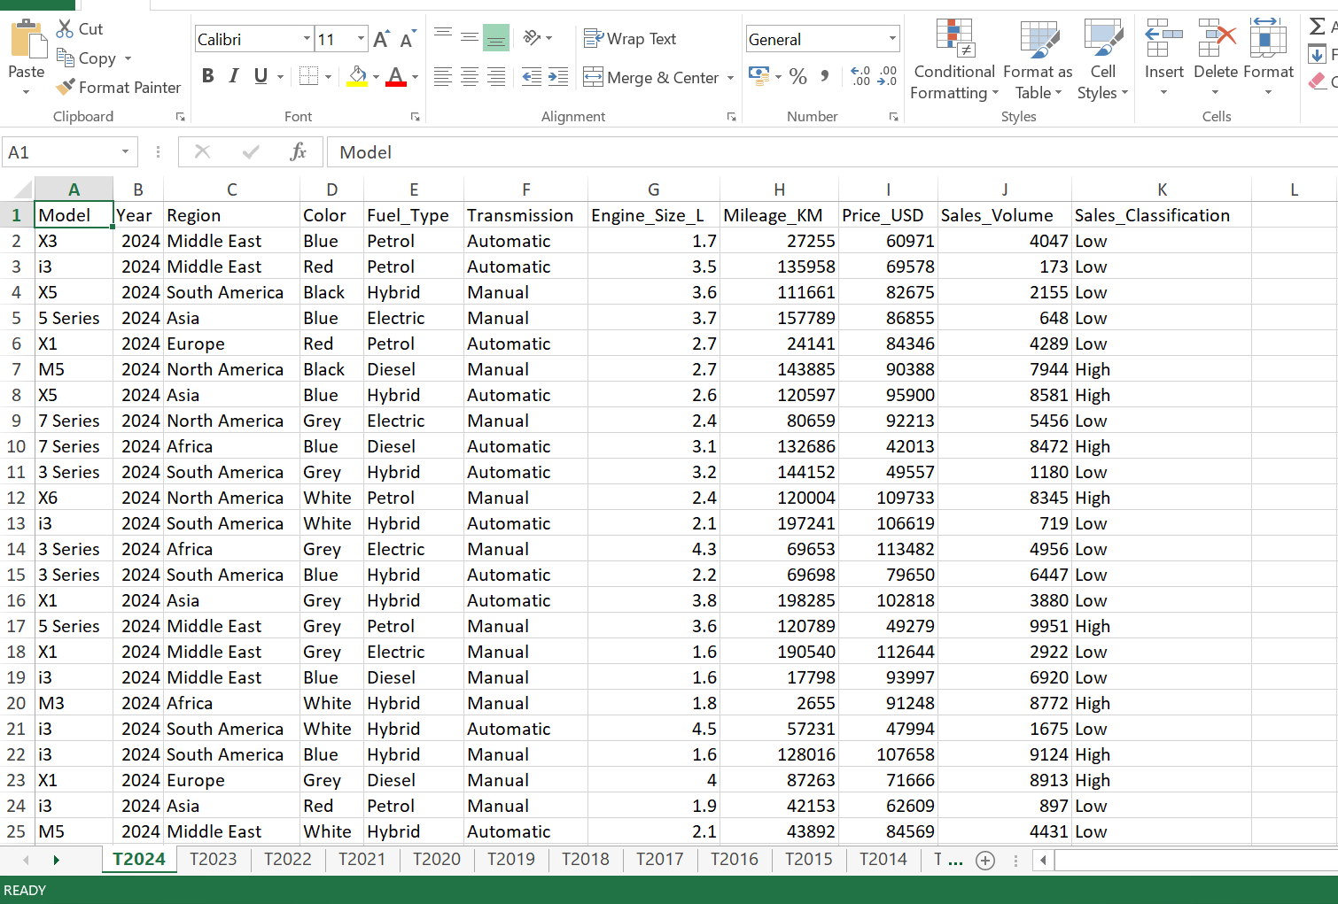

QUESTION TWO

STEPS INVOLVED
Step1; open and launch MATLAB
Step 2; click on new script to open editor
Step 3; Aquaring the number of group members
Step 4; generating a MATLAB code that can store each member’s attributes like age, date of birth, district etc.
Step 5; in the generation we coded that the matlab will determine the size of the table according to the number of members in the group
Step 6; in the next line we made a table by first describing type of variables, variable names.
Step 7;we coded that the user of the code should first describe the number of entrants
Step 8; we coded that the user should first enter one person at a go and when the number n is reached it draws the table automatically
Step 9; we coded that the code will ask to give a given variable name before filling the next one
NB : we coded that in the column of age the only variable type to be used is a “double”
Step 10; we displayed the table with a sample of two entrants as shown below
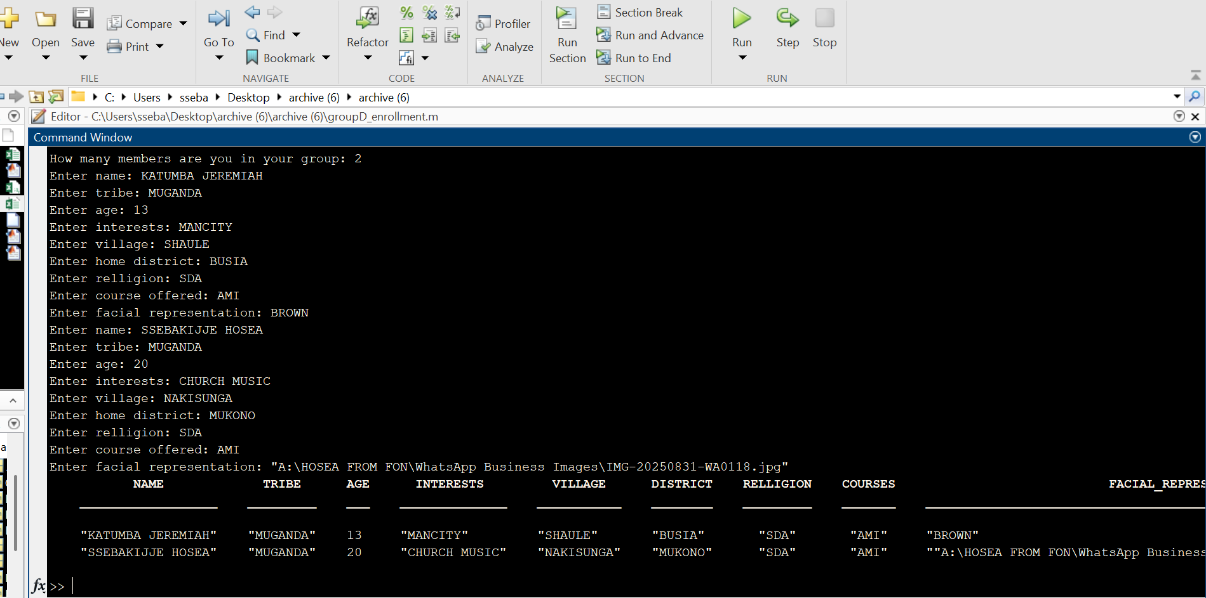

QUESTION TWO
%creation of table
clc; clear;
T= table('Size',[0 9],'VariableTypes',{'string','string','double','string','string','string','string','string','string'},'VariableNames',{'NAME','TRIBE','AGE','INTERESTS','VILLAGE','DISTRICT','RELLIGION','COURSES','FACIAL_REPRESENTATION'});
%number of group members
n=input('How many members are you in your group: ');
for k=1:n

NAME=input('Enter name: ','s');
TRIBE=input('Enter tribe: ','s');
AGE=input('Enter age: ');
INTERESTS=input('Enter interests: ','s');
VILLAGE=input('Enter village: ','s');
DISTRICT=input('Enter home district: ','s');
RELLIGION=input('Enter relligion: ','s');
COURSES=input('Enter course offered: ','s');
FACIAL_REPRESENTATION=input('Enter facial representation: ','s');
%storing into table
T(k,:)={string(NAME),string(TRIBE),AGE,string(INTERESTS),string(VILLAGE),string(DISTRICT),string(RELLIGION),string(COURSES),string(FACIAL_REPRESENTATION)};
end
%showing final table
disp(T);

Conclusion
The assignment was successful since there was maximum cooperation among group D members. It exposed us to the different computation skills on how to import, retrieve and to compile large sums of data using MATLAB. It also exposed us to use different websites like Kaggle.com where we obtained our excel dataset for number one

